# DESIGN

Main

# Initialize Scanner input

# Output: “Enter the integers between 1 and 100: “

# Input: String providedValue

# initialize int array numberList

# Loop through providedValue, and for each integer listed, increment numberList[] by 1

# Loop through numberList[]

# Initialize String timeSingularOrPlural with value “time”

# for each array element in numberList

# if the content of that element is greater than 0:

# output: value “occurs “ number of element “time” (with no lf)

# if the content of the element is > 1:

# output: “s”

# output: a line feed

Design

# TEST PLAN

|  |  |  |
| --- | --- | --- |
| Test # | Input | Expected Output |
| 1 | 2 5 6 5 4 3 23 43 2 0 | 2 occurs 2 times  3 occurs 1 time  4 occurs 1 time  5 occurs 2 times  6 occurs 1 time  23 occurs 1 time  43 occurs 1 time |
| 2 | 1 55 23 94 77 22 22 33 55 88 88 4 94 0 | 1 occurs 1 time  4 occurs 1 time  22 occurs 2 times  23 occurs 1 time  33 occurs 1 time  55 occurs 2 times  77 occurs 1 time  88 occurs 2 times  94 occurs 2 times |
| 3 | 2 5 33 55 88 88 6 5 4 3 23 33 55 88 88 33 55 88 88 43 2 0 | 2 occurs 2 times  3 occurs 1 time  4 occurs 1 time  5 occurs 2 times  6 occurs 1 time  23 occurs 1 time  33 occurs 3 times  43 occurs 1 time  55 occurs 3 times  88 occurs 6 times |

# SCREEN SHOTS

1

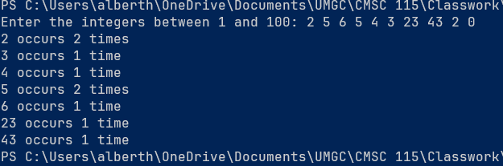

2

3

